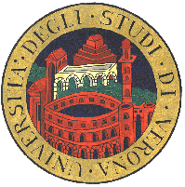 | Università degli Studi di Verona  Scuola di Dottorato di Scienze Ingegneria e Medicina

We certify that

NAME SURNAME

has actively participated to the Ph.D. course entitled

Advanced algorithms for the analysis and visualization of
DNA and protein sequences

held July 16 to 26, 2007
at the Dipartimento di Informatica of this University.

The Local Organizer | The Dean of the School

