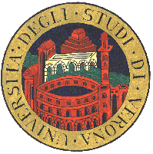 | Università degli Studi di Verona  Scuola di Dottorato di Scienze Ingegneria e Medicina | Ca' Vignal 2  Strada le Grazie 15  37134 Verona - Italia  Tel. +39 045 802 7069  Fax +39 045 802 7068

Dottorato di ricerca in Informatica

Graduate course in

Course Title

Month start-end date, year (hours)

Name of the Lecturer

Affiliation
address

Week 1 – July 16/19, 2007

dd/mm (14.30-17.30) - Title (3 hrs)
  - Course introduction
  - Global warming
  - Wars for oil
  - …

dd/mm (14.30-16.30) - Title (2 hrs)
  - Introduction
  - Atomic rush
  - Exploitation
  - …

dd/mm (14.30-16.30) - Title (2 hrs)
  - Introduction
  - Megacities
  - Pollution
  - …

Week 2 – July 23/26, 2007

dd/mm (14.30-16.30) - Title (2 hrs)
  - Introduction
  - Final Solution
  - Bye

Lectures will take place at the
Room
Place
Address

The course is supported by….

The admission to the course is FREE/EXPENSIVE. Attendees must submit an application via email to the Local organizer indicating their affiliation and current position by July 9, 2007.

Further info

Local organization and contact: Name Surname
email@domain

Web info: www.domain

